Order Of Service

Singing: Psalm 72—CW page 93

Reading: Psalm 51

Opening Hymn: CW 50

Reading: Galatians 4:8-20

Request Hymn: CW Supplement 763

Reading: Mark 9:33-41

Sermon Hymn: CW 496

Sermon Text: Luke 19:1-10

In A Sycamore Tree

Prayer

The Apostles’ Creed, TLH page 12

Holy Communion

The Lord's Prayer

The Blessing

Closing Hymn: 53

************
Bible Study: Lambs: A Special Donkey
Sheep: Deuteronomy 1:19-27
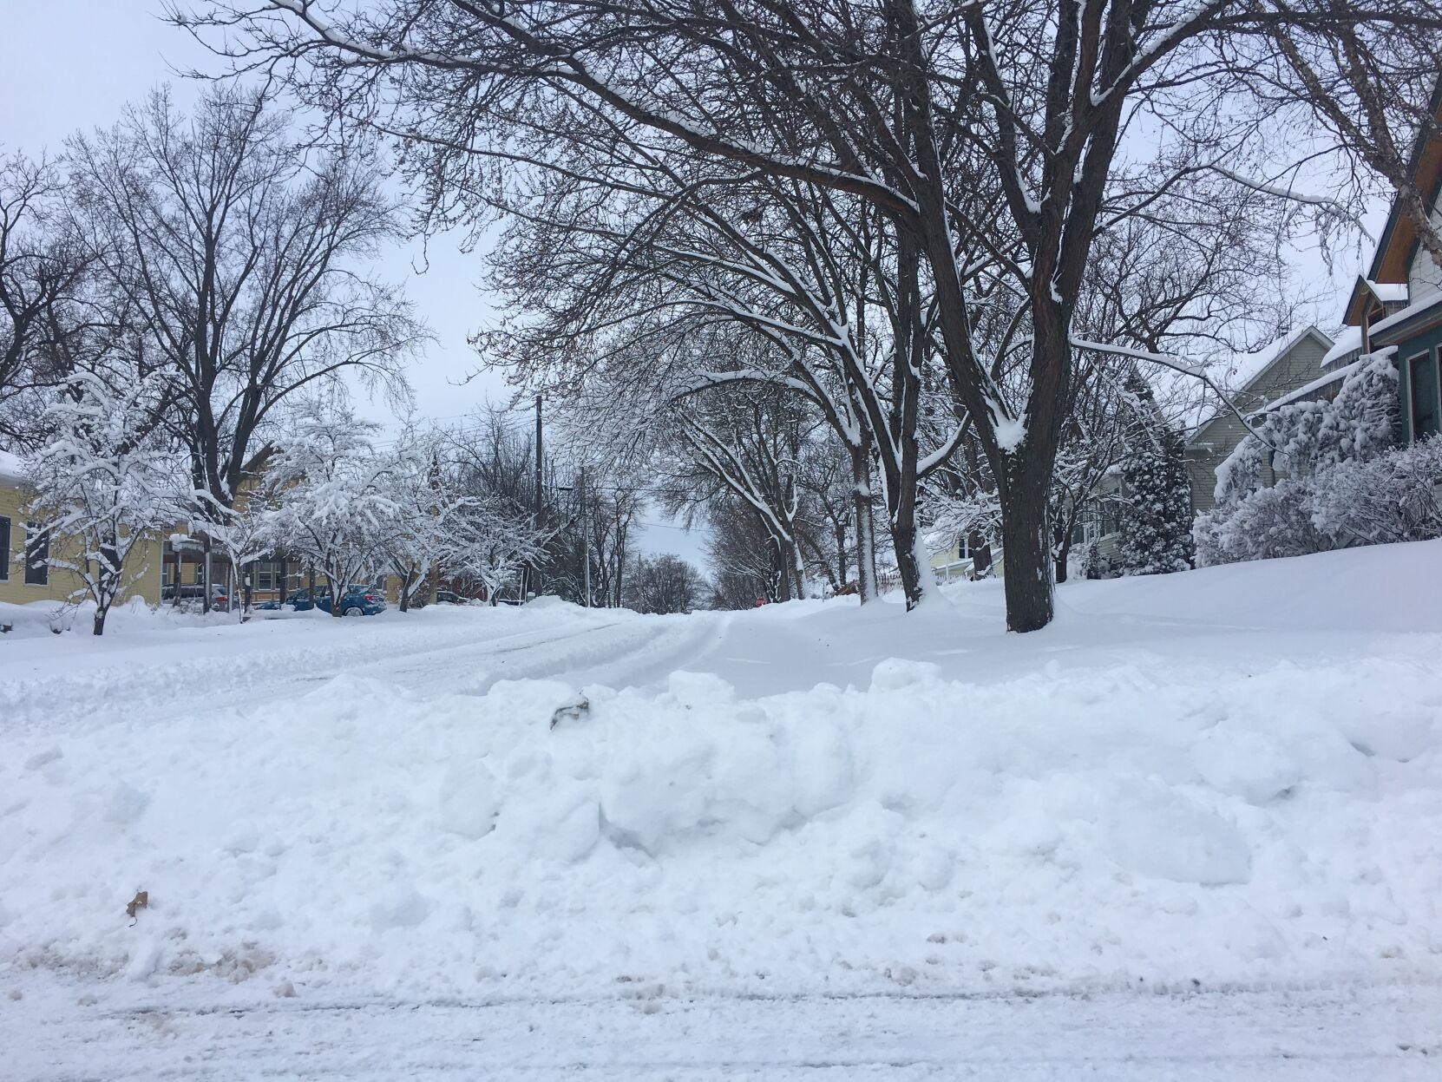

“Be Thou On The Earth”

Water
Of
Life

15 January 2023

W A T E R O F L I F E

Independent Christian Church—Conservative Lutheran Doctrine

Worship Service: 9:30 a.m.

Larry Cooper, Pastor E-Mail address:
111 N. Ridge Road lcooper@wateroflife.cc
Coon Valley, WI 54623 Web Site:
www.wateroflife.cc

* * * * * * * * * * * * * * * * * * * * * * * * * * *

Sermon Text: Luke 19:1-10

In A Sycamore Tree

* * * * * * * * * * * * * * * * * * * * * * * * * * *

1 And Jesus entered and passed through Jericho.
2 And, behold, there was a man named Zacchaeus, which was the chief among the publicans, and he was rich.
3 And he sought to see Jesus who he was; and could not for the press, because he was little of stature.
4 And he ran before, and climbed up into a sycomore tree to see him: for he was to pass that way.
5 And when Jesus came to the place, he looked up, and saw him, and said unto him, Zacchaeus, make haste, and come down; for to day I must abide at thy house.
6 And he made haste, and came down, and received him joyfully.
7 And when they saw it, they all murmured, saying, That he was gone to be guest with a man that is a sinner.
8 And Zacchaeus stood, and said unto the Lord; Behold, Lord, the half of my goods I give to the poor; and if I have taken any thing from any man by false accusation, I restore him fourfold.
9 And Jesus said unto him, This day is salvation come to this house, forsomuch as he also is a son of Abraham.
10 For the Son of man is come to seek and to save that which was lost.

